KPI Report

1 . Total Sales :

SELECT SUM (sales) AS Total Sales

FROM [SAMPLESUPERSTORE].[dbo].[Sample Superstore]

Output: 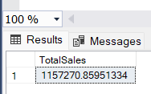

2 . Profit Margin :

SELECT

SUM(Profit) AS TotalProfit,

SUM(Sales) AS TotalSales,

(SUM(Profit) / SUM(Sales)) * 100 AS ProfitMargin

FROM

[SAMPLESUPERSTORE].[dbo].[Sample Superstore]

;

Output :

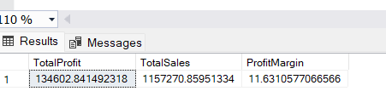

3. Average Sales Per Order

SELECT

AVG(Sales) AS AverageSalesPerOrder

FROM

[SAMPLESUPERSTORE].[dbo].[Sample Superstore]

;

Output : 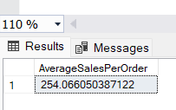

4. Total Orders

SELECT COUNT(DISTINCT Order_id) AS total_Orders

FROM [SAMPLESUPERSTORE].[dbo].[Sample Superstore]

;

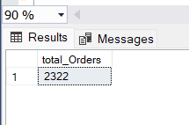

5 .Sales by State

SELECT TOP 10

State,

SUM(Sales) AS Total_Sales_By_State

FROM

[SAMPLESUPERSTORE].[dbo].[Sample Superstore]

GROUP BY

State;

Output: 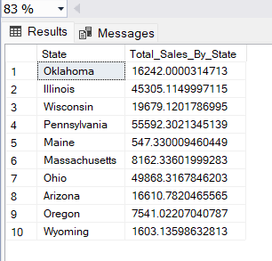

6. Sales by City

SELECT TOP 10

City,

SUM(Sales) AS Total_Sales_By_City

FROM

[SAMPLESUPERSTORE].[dbo].[Sample Superstore]

GROUP BY

City;

OUTPUT:

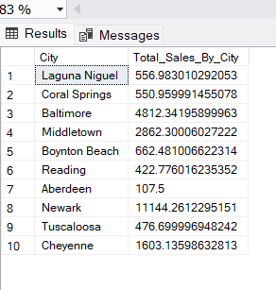

7 . Sales by Region

SELECT Region, SUM(Sales) AS TotalSales

FROM [SAMPLESUPERSTORE].[dbo].[Sample Superstore]

GROUP BY Region

ORDER BY TotalSales DESC

;

Output : 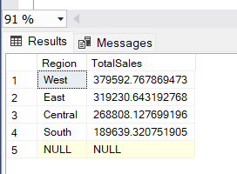

8. Sales Category

SELECT Category, SUM(sales) AS TotalSales

FROM [SAMPLESUPERSTORE].[dbo].[Sample Superstore]

GROUP BY Category

ORDER BY TotalSales DESC ;

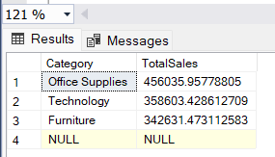

9. Sub Category Sales

SELECT Sub_Category, SUM(sales) AS TotalSales

FROM [SAMPLESUPERSTORE].[dbo].[Sample Superstore]

GROUP BY Sub_Category

ORDER BY TotalSales DESC ;

OUTPUT :

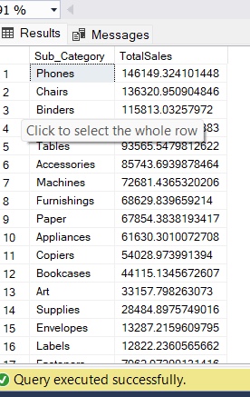



10. Payment Mode By Sales

SELECT Payment_Mode, SUM(Sales) AS TotalSales

FROM [SAMPLESUPERSTORE].[dbo].[Sample Superstore]

GROUP BY Payment_Mode

ORDER BY TotalSales DESC;

Output:

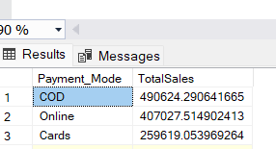

11. Ship_Mode Frequency

SELECT Ship_Mode, COUNT(*) AS Frequency

FROM [SAMPLESUPERSTORE].[dbo].[Sample Superstore]

GROUP BY Ship_Mode

ORDER BY Frequency DESC

;

Output : 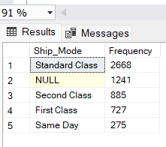

12. Unique Order_ID

SELECT

CONCAT(Order_ID, '_', Customer_ID, '_', Order_Date) AS Unique_Order_ID

FROM

[SAMPLESUPERSTORE].[dbo].[Sample Superstore]

;

OUTPUT :

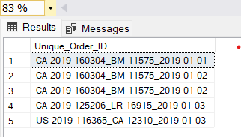

13. Top 5 Selling Products

SELECT TOP 5

Product_Name,

SUM(Sales) AS TotalSales

FROM [SAMPLESUPERSTORE].[dbo].[Sample Superstore]

GROUP BY

Product_Name

ORDER BY

TotalSales DESC;

Output :

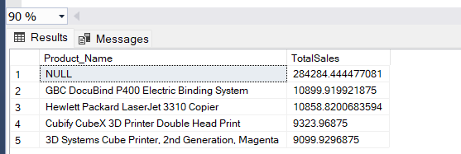

14.Bottom 5 Selling products

SELECT TOP 5

Product_Name,

SUM(Sales) AS TotalSales

FROM [SAMPLESUPERSTORE].[dbo].[Sample Superstore]

GROUP BY

Product_Name

ORDER BY

TotalSales ASC

;

OUTPUT :

